# Assignment -3 Bucket And Watson assistant

|  |  |
| --- | --- |
| Assignment Date | 7 October 2022 |
| Team ID | PNT2022TMID53909 |
| Student Name | Harini P |
| Student Roll Number | 95071915012 |
| Maximum Marks | 2 Marks |

**Questions:**

# Create a Bucket in IBM object storage.

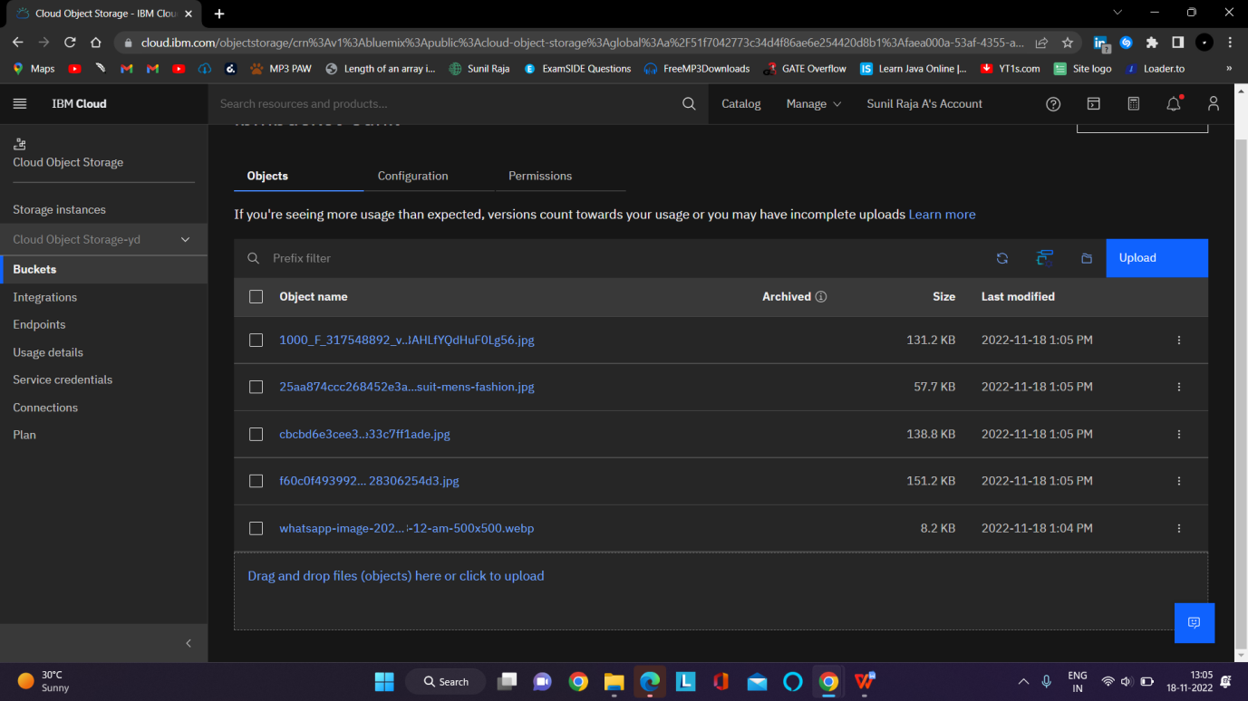

1. **Upload an 5 images to ibm object storage and make it public. write html code to displaying all the 5 images.**

# Index.html

<!DOCTYPE *html*>

<html *lang*="en">

<head>

<meta *charset*="UTF-8">

<meta *http-equiv*="X-UA-Compatible" *content*="IE=edge">

<meta *name*="viewport" *content*="width=device-width, initial-scale=1.0">

<title>Smart Fashion shop </title>

<style>

body {

background-color: aqua; display: flex;

align-items: center; justify-content: center;

flex-direction: column;

}

img {

height: 240px; border-radius: 10px; margin: 10px;

}

</style>

</head>

<body>

<h1>Wellcom To Fashion Store</h1>

<div>

<img *src*="https://ibmbucket-sunil.s3.ap.cloud-object- storage.appdomain.cloud/alex-haigh-fEt6Wd4t4j0-unsplash.jpg"

*alt*="Dress" *srcset*="">

<img *src*="https://ibmbucket-sunil.s3.ap.cloud-object- storage.appdomain.cloud/faith-yarn-Wr0TpKqf26s-unsplash.jpg"

*alt*="Dress" *srcset*="">

<img *src*="https://ibmbucket-sunil.s3.ap.cloud-object- storage.appdomain.cloud/haryo-setyadi-acn5ERAeSb4-unsplash.jpg"

*alt*="Dress" *srcset*="">

<img *src*="https://ibmbucket-sunil.s3.ap.cloud-object- storage.appdomain.cloud/ryan-hoffman-6Nub980bI3I-unsplash.jpg"

*alt*="Dress" *srcset*="">

<img *src*="https://ibmbucket-sunil.s3.ap.cloud-object- storage.appdomain.cloud/yves-monrique-LR99Ho2eIec-unsplash.jpg"

*alt*="Dress" *srcset*="">

</div>

</body>

</html>

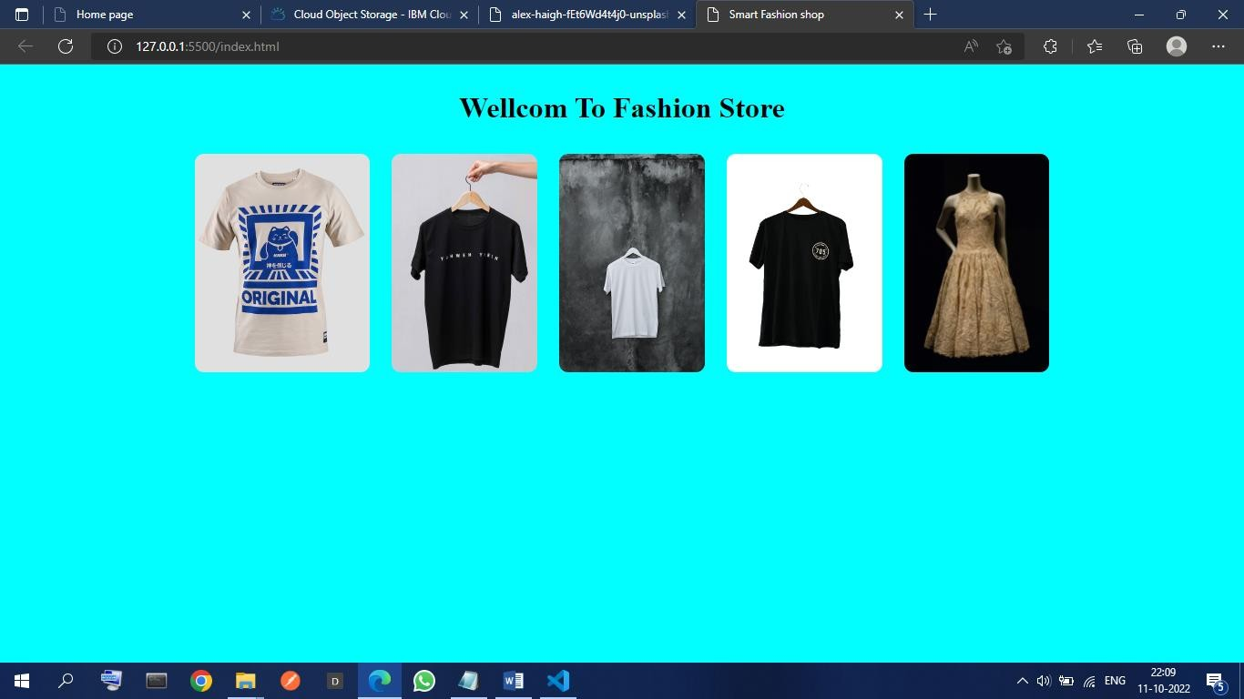

# Upload a css page to the object storage and use the same page in your HTML code.

<!DOCTYPE *html*>

<html *lang*="en">

<head>

<meta *charset*="UTF-8">

<meta *http-equiv*="X-UA-Compatible" *content*="IE=edge">

<meta *name*="viewport" *content*="width=device-width, initial-scale=1.0">

<title>Smart Fashion shop </title>

<link *rel*="stylesheet" *href*="https://ibmbucket-sunil.s3.ap.cloud-object- storage.appdomain.cloud/style.css">

</head>

<body>

<h1>Wellcom To Fashion Store</h1>

<div>

<img *src*="https://ibmbucket-sunil.s3.ap.cloud-object- storage.appdomain.cloud/alex-haigh-fEt6Wd4t4j0-unsplash.jpg"

*alt*="Dress" *srcset*="">

<img *src*="https://ibmbucket-sunil.s3.ap.cloud-object- storage.appdomain.cloud/faith-yarn-Wr0TpKqf26s-unsplash.jpg"

*alt*="Dress" *srcset*="">

<img *src*="https://ibmbucket-sunil.s3.ap.cloud-object- storage.appdomain.cloud/haryo-setyadi-acn5ERAeSb4-unsplash.jpg"

*alt*="Dress" *srcset*="">

<img *src*="https://ibmbucket-sunil.s3.ap.cloud-object- storage.appdomain.cloud/ryan-hoffman-6Nub980bI3I-unsplash.jpg"

*alt*="Dress" *srcset*="">

<img *src*="https://ibmbucket-sunils3.ap.cloud-object- storage.appdomain.cloud/yves-monrique-LR99Ho2eIec-unsplash.jpg"

*alt*="Dress" *srcset*="">

</div>

</body>

</html>

# Output:-



1. **Design a chatbot using IBM Watson assistant for hospital. Ex: User comes with query to know the branches for that hospital in your city. Submit the web URL of that chat bot as a assignment.**

Url : (Watson Chatbot) https://web-chat.global.assistant.watson.appdomain.cloud/preview.html?backgroundImageURL=https%3A%2F%2Fau-syd.assistant.watson.cloud.ibm.com%2Fpublic%2Fimages%2Fupx-e8783142-c320-45c5-ac72-97c6bec25b28%3A%3A824a93a2-f19c-4ae7-9110-d32d76ca1517&integrationID=fa364fcf-c04b-432f-b34b-8142cd84d652&region=au-syd&serviceInstanceID=e8783142-c320-45c5-ac72-97c6bec25b28

# C:\Users\USER\Pictures\Screenshots\Screenshot (1108).pngScreenshot (1108)

**5 .Create Watson assistant service with 10 steps and use 3 conditions in it. Load that script in HTML page**

